**Mapping the 1854 London Cholera Outbreak**

Dr. John Snow is regarded as one of the founding fathers of modern epidemiology.  As London suffered a series of cholera outbreaks during the mid-19th century, Snow theorized that cholera reproduced in the human body and was spread through contaminated water.  This contradicted the prevailing theory that diseasses were spread by "miasma" in the air.

London's water supply system consisted of shallow public wells where people could pump their own water to carry home, and about a dozen water utilities that drew water from the Thames to supply a jumble of water lines to more upscale houses. London's sewage system was even more ad hoc: privies emptied into cesspools or cellars more often than directly into sewer pipes. So the pervasive stench of animal and human feces combined with rotting garbage made the miasma theory of disease seem very plausible. Disease was more prevalent in lower-class neighborhoods because they stank more, and because the supposed moral depravity of poor people weakened their constitutions and made them more vulnerable to disease.

The September 1854 cholera outbreak was centered in the Soho district, close to Snow's house. Snow mapped the 13 public wells and all the known cholera deaths around Soho, and noted the spatial clustering of cases around one particular water pump on the southwest corner of the intersection of Broad (now Broadwick) Street and Cambridge (now Lexington) Street.  He examined water samples from various wells under a microscope, and confirmed the presence of an unknown bacterium in the Broad Street samples. Despite strong scepticism from the local authorities, he had the pump handle removed from the Broad Street pump and the outbreak quickly subsided.

Snow subsequently published a map of the epidemic to support his theory. A detail fom this map is shown below.  The nated[complete map](https://www1.udel.edu/johnmack/frec682/cholera/snow_map.png) shows the locations of the 13 public wells in the area, and the 578 cholera deaths mapped by home address, marked as black bars stacked perpendicular to the streets.

[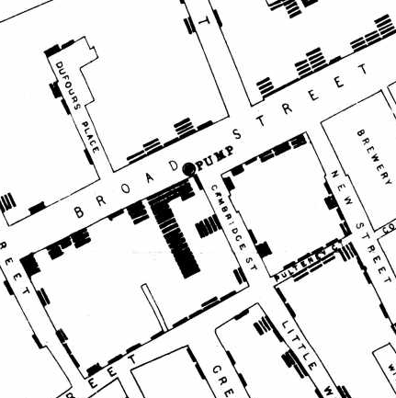](https://www1.udel.edu/johnmack/frec682/cholera/snow_map.png)

Some anomalies are worth noting. Although the large workhouse just north of Broad Street housed over 500 paupers, it suffered very few cholera deaths because it had its own well (not shown on the map).  Likewise, The workers at the brewery one block east of the Broad Street pump could drink all the beer they wanted; the fermentation killed the cholera bacteria, and none of the brewery workers contracted cholera. Many of the deaths further away from the Broad Street pump were people who walked to work or market on the Broad Street and drank from that well. The water from the Broad Street well reportedly tasted better than water from most of the neighboring wells, particularly the smelly water from the Carnaby Street/Little Marlborough Street well a few blocks to the northeast.

Steven Johnson's 2006 book *The Ghost Map: the Story of London's Most Terrifying Epidemic, and How it Changed Science, Cities and the Modern World* (available in paperback) is a highly entertaining account of the epidemic and Snow's analysis of it.

[Analysis of Dr. Snow's map](https://www1.udel.edu/johnmack/frec682/cholera/cholera2.html)